

ASSET VERIFICATION AND RECORDING TOOL KIT


Plot 31, Bukoto Street
P.O Box 7657, Kampala, Uganda
+256 (0) 39 2000216/0772525235
email: cpa@cpa.ug

www.cpa.com

August to September 2026

VERIFICATION DETAILS

NAME OF THE REGION: | NORTH CENTAL
SUB-REGION:
Name of Local Government | KYANKWANZI
VERIFIER PARTICULARS
Full name | NAKITENDE SHARIFAH  FATUMA YASIN  NAKAGWA HINDU
Contact/ email and Telephone
Supervisor/ Sub team leader
Name

Contact
Date of submission

HEALTH CENTRES
INFORMANT INTERVIEW/DISCUSSION GUIDE (INCHARGE OR RESPONSIBLE PERSON)

Name of Health Centre: KIKOMA HEALTH CENTER III

1a | Does the Facility have a record of all assets provided under UgIFT.  (Obtain a record and verify if it has the costs and numbers supplied | YES
1b | If Not ask how many were supplied and when.

2 | How does this facility Maintain (repair/service/replace) the assets provided under Ugift  B y repairing them (Mubende Region)

3 | Does the facility take regular record about functionality/ or breakdown of the assets provided? | Yes, Every after 6 months

4 | How has the UgIFT support helped in service delivery in the area, any issues, challenges and any recommendations for better program implementation. | - Poor electricity  - Lack of water

PROCEED TO VERIFICATION AFTER THIS DISCUSSION

Health centre checklist

NAME OF LG………………………………………… NAME OF HEALTH FACILITY…………………………………………………………

Equipment/ Item | Department | Asset Number | Item  Description | Life in Months | Tag Number ( engrave no.) | Date Of Purchase | Date Placed In Service | Recoverable cost | Cost | Acc Dep Cost | Net Book Value | Ytd Deprn | Equipment status | Remarks
B.P. Machine, Digital
B.P. Machine (Aneroid wall mounted)
02 | OPD |  | BLACK,GREY |  | KKMHC111/OF/03 |  |  |  |  |  |  |  | FUNCTIONING | IN USE
Autoclave 20 Liters.,Duo Operated  02 | MAT&  STORE |  |  |  | KKMHC111/OF/03 |  |  |  |  |  |  |  | FUNCTIONING | 1 IN USE 1 IN STORE
Bowl, Kick | MAT |  |  |  | KKMHC111/OF/03 |  |  |  |  |  |  |  | FUNCTIONING | IN USE
02
Bowl Stand | MAT |  | SLIVER |  | KKMHC111/OF/03 |  |  |  |  |  |  |  | FUNCTIONING | IN USE
04
Counting chamber Neubauer- Improved | LAB |  |  |  | KKMHC111/OF/03 |  |  |  |  |  |  |  | FUNCTIONING | IN USE
04
Cupboard Steel, Lockable | MAT, OPD,  OFFICES |  | OFF WHITE |  | KKMHC111/OF/03
06
Drip Stand | WARD |  | BLUE,WHITE,SLIVER |  | KKMHC111/OF/03 |  |  |  |  |  |  |  | FUNCTIONING | IN USE
06
ESR Stand | MAT |  | SLIVER, BLACK |  | KKMHC111/OF/03 |  |  |  |  |  |  |  | FUNCTIONING | IN USE
02
Examination Couch | MAT, STORE |  | BLACK, GREY |  | KKMHC111/OF/03 |  |  |  |  |  |  |  | FUNCTIONING | IN USE
04
Examination light,LED | MAT,  STORE |  | WHITE |  | KKMHC111/OF/03 |  |  |  |  |  |  |  | FUNCTIONING | IN USE
04
Glucometer
01 | LAB |  | BLACK |  | KKMHC111/OF/03 |  |  |  |  |  |  |  | FUNCTIONING | IN USE
Haemoglobin Meter, Digital
04 | LAB, STORE |  | RED,  STORE |  | KKMHC111/OF/03 |  |  |  |  |  |  |  | FUNCTIONING | 2 IN LAB,2 IN STORE
Height Meter | OPD  ,MAT |  | GREY,WHITE |  | KKMHC111/OF/03 |  |  |  |  |  |  |  | FUNCTIONING | IN USE
02
Instrument Trolley
02 | MAT, OPD |  | SLIVER |  | KKMHC111/OF/03 |  |  |  |  |  |  |  | FUNCTIONNG | IN USE
Microscope Binocular | LAB, STORE |  | CREAM |  | KKMHC111/OF/03 |  |  |  |  |  |  |  | FUNCTIONING | 1 IN LAB,  1 STORE
02
Otoscope | OPD, MAT |  | BLACK |  | KKMHC111/OF/03 |  |  |  |  |  |  |  | FUNCTIONING | IN USE
02
Patient Screen
10 | POSTNENTO WARD, WARD, MAT |  | BLUE,SLIVER |  | KKMHC111/OF/03 |  |  |  |  |  |  |  | FUNCTIONING | IN USE
Patient Trolley | OPD,  MAT |  | WHITE |  | KKMHC111/OF/03 |  |  |  |  |  |  |  | FUNCTIONING | IN USE
02
Refrigerator, Basic | LAB,  MAT |  | GREY |  | KKMHC111/OF/03 |  |  |  |  |  |  |  | FUNCTIONING | IN USE
02
Stethoscope | OPD  MAT |  | BLUE |  | KKMHC111/OF/03 |  |  |  |  |  |  |  | FUNCTIONING | IN UDE
08
Stop Watch | LAB |  | WHITE, GREY |  | KKMHC111/OF/03 |  |  |  |  |  |  |  | FUNCTIONING | IN USE
02
Stretcher | OPD ,  WARD,  MAT |  |  |  | KKMHC111/OF/03 |  |  |  |  |  |  |  | FUNCTIONING | IN USE
04
Stove, Gas | MAT |  | SLIVER |  | KKMHC111/OF/03 |  |  |  |  |  |  |  | FUNCTIONING | IN USE
02
Weighing Scale with Height Meter, Adult | MAT,  OPD |  | WHITE |  | KKMHC111/OF/03 |  |  |  |  |  |  |  | FUNCTIONING | IN USE
04
Weighing Scale, Infant | MAT |  | GREY |  | KKMHC111/OF/03 |  |  |  |  |  |  |  | FUNCTIONING | IN USE
04
Weighing Scale, Toddler | EPI |  | WHITE |  | KKMHC111/OF/03 |  |  |  |  |  |  |  | FUNCTIONING | IN USE
04
Wheel Chair | OPD  MAT |  | BLACK |  | KKMHC111/OF/03 |  |  |  |  |  |  |  | FUNCTIONING | IN USE
04
Audio Visual Equipment
Medical Waste Bin | EVERY  DEPT |  | SLIVER WITH A PEDAL |  | KKMHC111/OF/03 |  |  |  |  |  |  |  | FUNCTIONING | IN USE
20
Wall Clock
Diagnostic Equipment Set for MCH | MAT |  | SLIVER |  | KKMHC111/OF/03 |  |  |  |  |  |  |  | FUNCTIONING | IN USE
03
Diagnostic Equipment Set for OPD | OPD |  | SLIVER |  | KKMHC111/OF/03 |  |  |  |  |  |  |  | FUNCTIONING | IN USE
03
Glassware Set, Laboratory, Basic | LAB |  |  |  | KKMHC111/OF/03 |  |  |  |  |  |  |  | FUNCTIONING | IN USE
03
Hollow Ware Set, Treatment | WARD |  |  |  | KKMHC111/OF/03 |  |  |  |  |  |  |  | FUNCTIONING | IN USE
03
Instrument Set, Dressing | OPD |  | SLIVER |  | KKMHC111/OF/03 |  |  |  |  |  |  |  | FUNCTIONING | IN USE
03
Instrument Set, Basic ENT | OPD |  | SLIVER |  | KKMHC111/OF/03 |  |  |  |  |  |  |  | FUNCTIONING | IN USE
03
Instrument Set, Suture | OPD  MAT |  |  |  | KKMHC111/OF/03 |  |  |  |  |  |  |  | FUNCTIONING | IN USE
03
Pulse Oximeter, Hand held
Bed, Adult Patient with Mattress | FEMALE WARD  MALE WARD |  | BLUE,  WHITE |  | KKMHC111/OF/03 |  |  |  |  |  |  |  | FUNCTIONING | IN USE
20
Bed, Pediatric Patient, With Mattress | PEDIATRIC WARD |  | PINK,BLUE, WHITE |  | KKMHC111/OF/03 |  |  |  |  |  |  |  | FUNCTIONING | IN USE
10
Bedside Locker | EVERY DEPT |  |  |  | KKMHC111/OF/03 |  |  |  |  |  |  |  | FUNCTIONING | IN USE
10
Cupboard, Instrument | MAT |  | GREY |  | KKMHC111/OF/03 |  |  |  |  |  |  |  | FUNCTIONING | IN USE
01
Delivery Bed, Hydraulic Manual
Oxygen Therapy Apparatus, Mininum 45L cylinder | PEDIRIATIC WARD,  MAT,  STORE |  |  |  | KKMHC111/OF/03 |  |  |  |  |  |  |  | FUNCTIONING | IN USE
05
Resuscitator Manual, Infant, with all Mask sizes | KANGARO |  | WHITE |  | KKMHC111/OF/03 |  |  |  |  |  |  |  | FUNCTIONING | IN USE
15
Resuscitator Manual, Adult, with all mask sizes | MAT |  | WHITE |  | KKMHC111/OF/03 |  |  |  |  |  |  |  | FUNCTIONING | IN USE
15
Suction Apparatus, (Electric) | MAT |  | WHITE |  | KKMHC111/OF/03 |  |  |  |  |  |  |  | FUNCTIONING | IN USE
03
Nebulizer, Ultrasonic | WARD |  |  |  | KKMHC111/OF/03 |  |  |  |  |  |  |  | FUNCTIONING | IN USE
01
Oxygen Concentrator, Duo Flow | KANGARO, MAT |  | GREY |  | KKMHC111/OF/03 |  |  |  |  |  |  |  | FUNCTIONING | IN USE
04
Bench | MAT |  | BLACK, BROWN |  | KKMHC111/OF/03 |  |  |  |  |  |  |  | FUNCTIONING | IN USE
04
Disinfection Buckets
Baby Cot
Diagnostic Equipment Set for Ward
Hollow Ware Set, Ward
Instrument Set, Delivery
Instrument Set, Stitch Removing
MVA Kit | MAT |  |  |  | KKMHC111/OF/03 |  |  |  |  |  |  |  | FUNCTIONING | IN USE
05
Stool, Laboratory | LAB |  |  |  | KKMHC111/OF/03 |  |  |  |  |  |  |  | FUNCTIONING | IN USE
06
Penguin Sucker | MAT |  | WHITE |  | KKMHC111/OF/03 |  |  |  |  |  |  |  | FUNCTIONING | IN USE
03
Fetoscope, Dopplar | MAT |  | WHITE |  | KKMHC111/OF/03 |  |  |  |  |  |  |  | FUNCTIONING | IN USE
01
Bubble CPAP
Centrifuge (Electric) | LAB |  | GREEN |  | KKMHC111/OF/03 |  |  |  |  |  |  |  | FUNCTIONING | IN USE
04
Kangaroo Mother Care Chair | KANGARO |  |  |  | KKMHC111/OF/03 |  |  |  |  |  |  |  | FUNCTIONING | IN USE
01
Radiant Infant Warmer | MAT |  |  |  | KKMHC111/OF/03 |  |  |  |  |  |  |  | FUNCTIONING | IN USE
02
Haemoglobin Meter, Sahli
Delivery Bed | MAT |  |  |  | KKMHC111/OF/03 |  |  |  |  |  |  |  | FUNCTIONING | IN USE
02
Examination light | MAT |  |  |  | KKMHC111/OF/03 |  |  |  |  |  |  |  | FUNCTIONING | IN USE
04
Instrument set, ENT Basic for HCIII | OPD |  |  |  | KKMHC111/OF/03 |  |  |  |  |  |  |  | FUNCTIONING | IN USE
03
Bag Valve mask (Ambu Bag), Neonatal
Incubator
Office Chair | LAB INCHARGE 2 |  |  |  | KKMHC111/OF/03 |  |  |  |  |  |  |  | FUNCTIONING | IN USE
06 | ANC 1
 | DATA 1
 | ASS IN CHARGE 1
 | 1
Desk | LAB 1  ANC 1 |  |  |  | KKMHC111/OF/03 |  |  |  |  |  |  |  | FUNCTIONING | IN USE
05 | INCHARGE 1
 | DATA 1
 | C/O 1
Filing Cabinet | LABOUR SUIT 1 |  |  |  | KKMHC111/OF/03 |  |  |  |  |  |  |  | FUNCTIONING | IN USE
06
Non Residential Buildings | IMPATIENT |  | 12 ECEPTION |  | KKMHC111/OF/03
02 BLOCKS | LABOUR SUIT |  |  |  | KKMHC111/OF/03 |  |  |  |  |  |  |  | FUNCTIONING | IN USE
 | POSTNETO
Residential Buildings |  |  | EACH WITH 2 SELF CONTAINED ROOMS |  | KKMHC111/OF/03 |  |  |  |  |  |  |  | FUNCTIONING | IN USE
03 BLOCKPLACENTA PIT (1) |  |  |  |  | KKMHC111/OF/03 |  |  |  |  |  |  |  | FUNCTIONING | IN USE
PATIENTS PIT LATRINE (2) |  |  |  |  | KKMHC111/OF/03 |  |  |  |  |  |  |  | FUNCTIONING | IN USE
STAFF QUARTER TOILETS (03) |  |  |  |  | KKMHC111/OF/03 |  |  |  |  |  |  |  | FUNCTIONING | IN USE
WATER TANKS(9) 10,000 LTRS (2) 5000 LTRS(6), 1000 LTRS (6) |  |  |  |  | KKMHC111/OF/03 |  |  |  |  |  |  |  | FUCTIONING | IN USE
SOLAR |  |  |  |  | KKMHC111/OF/03 |  |  |  |  |  |  |  | FUCTIONING | IN USE
FIRE EXTINGUISHERS |  |  |  |  | KKMHC111/OF/03 |  |  |  |  |  |  |  | FUCTIONING | IN USE
NOTICES BOARDS (5) |  |  |  |  | KKMHC111/OF/03 |  |  |  |  |  |  |  | FUCTIONING | IN USE

APPENDIX

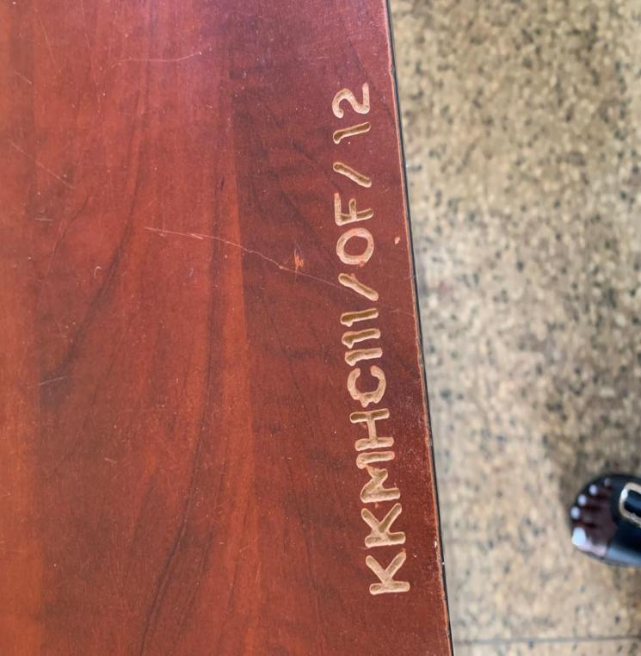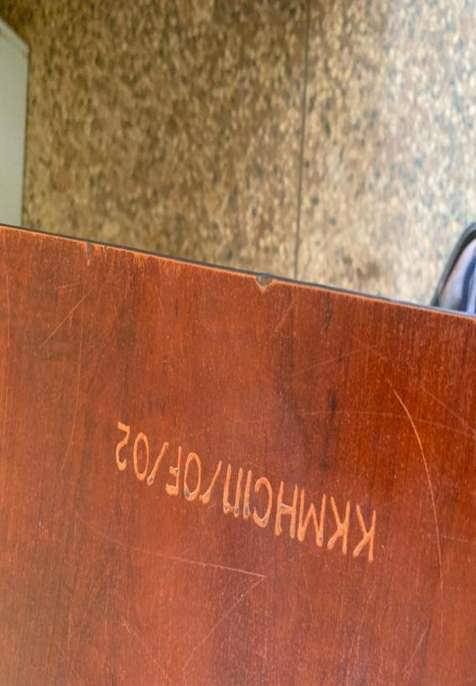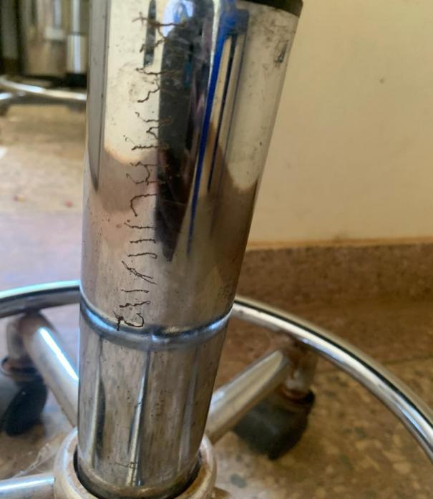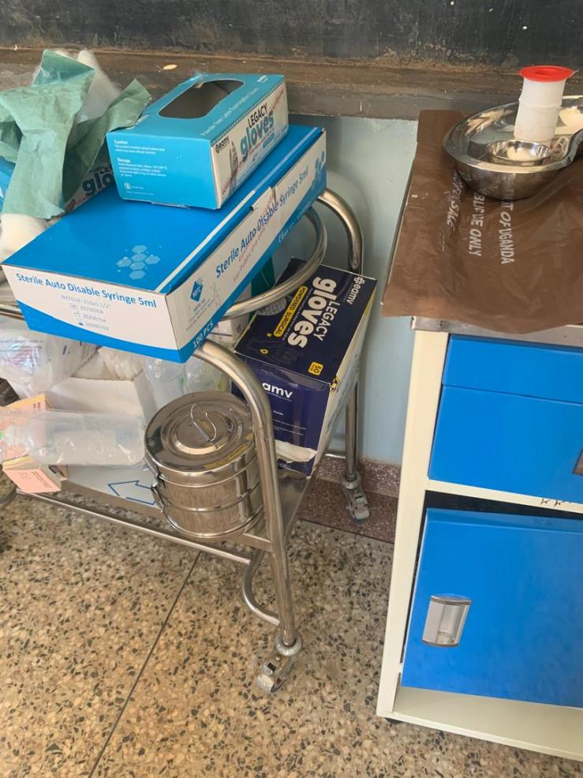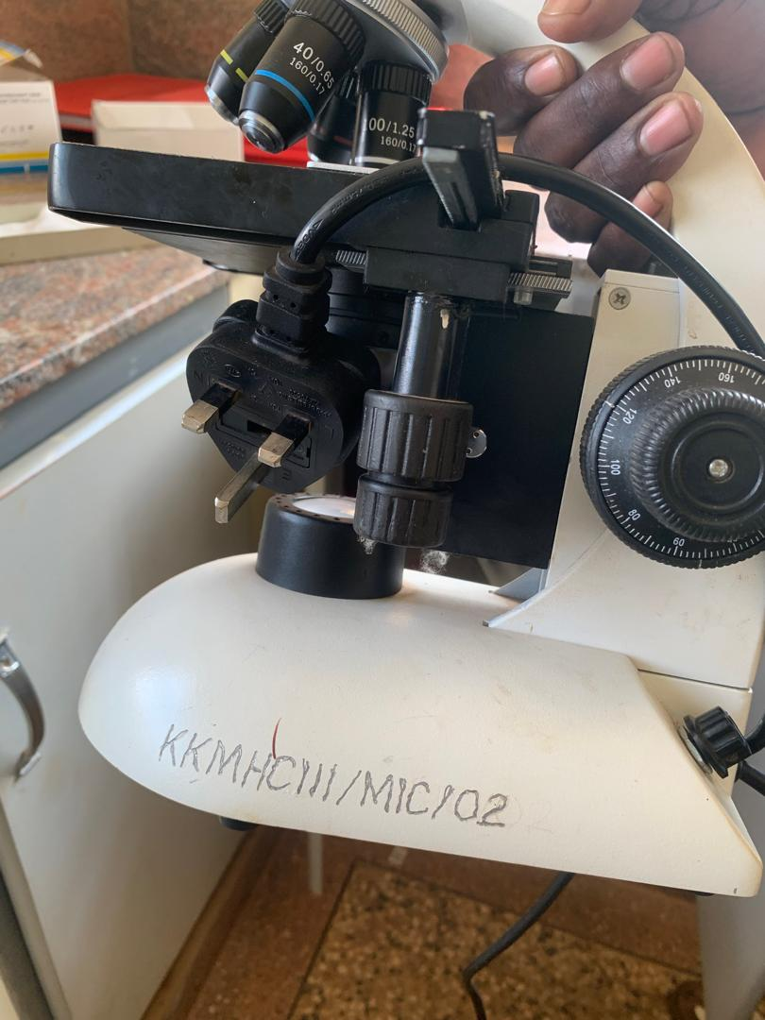

SCHOOL VERIFICATION CHECKLIST

SCHOOL INTERVIEW/DISCUSSION GUIDE

Name of school: BUNANYWA SEED SECONDARY SCHOOL

1a | Does the Facility have a record of all assets provided under UgIFT.  (Obtain a record and verify if it has the costs and numbers supplied | YES
1b | If Not ask how many were supplied and when. | 1162

2 | How does this facility Maintain (repair/service/replace) the assets provided under Ugift  By repairing them

3 | Does the facility take regular record about functionality/ or breakdown of the assets provided?  Nonfunctional/ working, and reasons for non-functionality. | YES

4 | How has the UgIFT support helped in service delivery in the area, any issues, challenges and any recommendations for better program implementation.

- Lunch for Leaners
- Transport during rainy season
- Lack of enough blocks

PROCEED TO VERIFICATION AFTER THIS DISCUSSION

SCHOOL FURNITURE
(School Desks, Office chairs, Laboratory stools, Book shelves)

Name of LG………………………………………………………………… Name of SCHOOL……………………………………………
Equipment/ Item | Department | Asset Number | Item  Description | Life in Months | Tag Number ( engrave no.) | Date Of Pur | Date Placed In Service | Recoverable cost | Cost | Acc Dep Cost | Net Book Value | Ytd Deprn | Equipment status | Remarks
3 Seater desks (119) | classrooms |  | Brown |  | NOT ENGRAVED |  |  |  |  |  |  | Functioning | Still in use
Teacher tables (12) | Staffroom |  | Brown |  | NOT ENGRAVED |  |  |  |  |  |  | Functioning | In use
Teacher chairs (12) | Staffroom |  | Brown,Black |  | NOT ENGRAVED |  |  |  |  |  |  | Functioning | In use
Labaratory stool (182) | Lab, Store |  | Brown, Black |  | NOT ENGRAVED |  |  |  |  |  |  | Functioning | 15 not in use
Lab tables (46) | Lab |  | Brown, Black |  | NOT ENGRAVED |  |  |  |  |  |  | All Functioning | In use
Teachers tables (12) | Staffroom |  | Brown, Black |  | NOT ENGRAVED |  |  |  |  |  |  | Functioning | In use
Lockable Shelves (17) | Staffroom |  | Brown, Black |  | NOT ENGRAVED |  |  |  |  |  |  | Functioning | In use
Office desks (3) | Office |  | Brown, Black |  | NOT ENGRAVED |  |  |  |  |  |  | Functioning | In use
Office chairs (3) | Office |  | Brown, Black |  | NOT ENGRAVED |  |  |  |  |  |  | Functioning | In use
Oppen Shelves (6) | Office |  | Functioning |  | NOT ENGRAVED |  |  |  |  |  |  | Functioning | In use
Chairs (303) | Library |  | Brown, Black |  | NOT ENGRAVED |  |  |  |  |  |  | 7 broken other in use | In use
Tables (113) | Library |  | Brown, Black |  | NOT ENGRAVED |  |  |  |  |  |  | Functioning | In use
Office chairs (19) | Office |  | Brown, Black |  | NOT ENGRAVED |  |  |  |  |  |  | Functioning | In use
Office desks (4) | Office |  |  |  | NOT ENGRAVED |  |  |  |  |  |  | Functioning | In use
Class rooms (6 blocks) | Compound |  |  |  | NOT ENGRAVED |  |  |  |  |  |  | Functioning | In use
Science lab (1 block) | Compound |  |  |  | NOT ENGRAVED |  |  |  |  |  |  | Functioning | In use
Multi purpose hall (1) | Compound |  |  |  | NOT ENGRAVED |  |  |  |  |  |  | Functioning | In use
Administration block (1) | Compound |  |  |  | NOT ENGRAVED |  |  |  |  |  |  | Functioning | In use
Staff houses (3 blocks) | Staff quators |  |  |  | NOT ENGRAVED |  |  |  |  |  |  | Functioning | In use
Kitchen (3 blocks) | Teachers quators |  |  |  | NOT ENGRAVED |  |  |  |  |  |  | Functioning | In use
2 Stance VIP (2 blocks) | Compound |  |  |  | NOT ENGRAVED |  |  |  |  |  |  | Functioning | In use
5 Stance VIP (2 Blocks) | Compound |  |  |  | NOT ENGRAVED |  |  |  |  |  |  | Functioning | In use
Computers (29) | Computer lab |  |  |  | NOT ENGRAVED |  |  |  |  |  |  | Functioning | In n use
Projector (1) | Classroom |  |  |  |  |  |  |  |  |  |  | Functioning | In use
Printer (1) | Computer Labaratory |  |  |  | NOT ENGRAVED |  |  |  |  |  |  | Functioning | In use
Water tank (3) | Compound |  |  |  | NOT ENGRAVED |  |  |  |  |  |  | Functioning | In use
Gas system (2) | Science lab |  |  |  | NOT ENGRAVED |  |  |  |  |  |  | Functioning | In use
Bunsen bunners (26) | Computer lab |  |  |  | NOT ENGRAVED |  |  |  |  |  |  | Functioning | In use
Din board (58) | Classrooms |  |  |  | NOT ENGRAVED |  |  |  |  |  |  | 12 are broken | 46 in use
Laptop (02) | Office |  |  |  | NOT ENGRAVED |  |  |  |  |  |  | Functioning | In use
Pitch | Compound |  |  |  | NOT ENGRAVED |  |  |  |  |  |  | Functioning | In use

ICT ITEMS TO VERIFY
(Desktop Computer, Server Processor, Network Switch 24 Port, Multipurpose Printer, UPS, Projector, Air Conditioners, Server, CCTV Camera)

Name of LG…………………………………………………………………………… Name of SCHOOL………………………….………………………………………

Equipment/ Item | Department | Asset Number | Item  Description | Life in Months | Tag Number ( engrave no.) | Date Of Pur | Date Placed In Service | Recoverable cost | Cost | Acc Dep Cost | Net Book Value | Ytd Deprn | Equipment status | Remarks

BUILDINGS TO VERIFY
(Non- Residential and Residential, Kitchen, Toilets/Pit latrine Water tanks, Fences etc.)

Name of LG…………………………………………………………………………… Name of SCHOOL………………………….………………………………………

Equipment/ Item | Department | Asset Number | Item  Description | Life in Months | Tag Number ( engrave no.) | Date Of Pur | Date Placed In Service | Recoverable cost | Cost | Acc Dep Cost | Net Book Value | Ytd Deprn | Equipment status | Remarks

APPENDX
